Magnet assembly

Magnetic assemblies are components made from permanent magnets and steel parts (and/or some non-ferrite magnetic insulate materials, such as Brass and Aluminum) fixed or bonded together. a magnetic assembly has a particular magnetic circuit that can concentrate or insulate magnetic power at a target space around the magnetic assembly. In this way, magnetic assemblies can be utilized for holding, retrieving, moving, lifting and mounting steel parts in different industrial applications.
we recommend you test actual pulling or holding force of magnet assembly in your application, instead of simply depending on the Maximum Pull, and consider safety factor before you buy magnetic assemblies.
We make magnet assemblies according to customers' drawing, requirements or samples.

Magnetic coupling

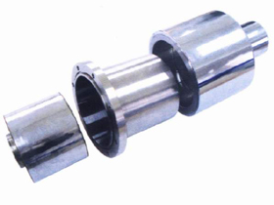
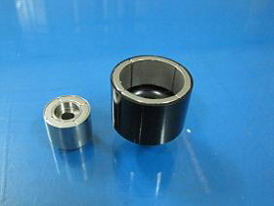
Magnetic coupling is a new kind of coupling,which connects motor and machine by permanent magnetic force.They work in the sealless magnetic drive pumps,which transporting volatile,flammable,explosive and toxic solutions with no leakage.
The appearance of Magnetic coupling solved thoroughly the leak problems existed in dynamic sealing of certain mechanical devices.Magneic coupling are widely used in various industries and fields,such as chemical,papermaking,foodstuff, pharmacy,and so on.Magnetic coulpling is consist of external rotor,internal rotor and isolating cover.

Magnetic stand
The products are widely used in mechanical processing,parts measuring,equipment correcting,for its reasonable structure,novel and protable features,with hundred-divided ruler and thousand-divided ruler.
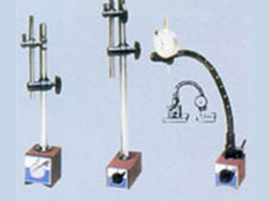

Model | Sort | Absorntion  strength | Outline |  |  | Stem |  |  | Screw  dianeter  on stem | Indicator  installation position |  | W  (kg) | Feature
Model | Sort | W | L | H | D | L1 | L2 | L3 | Screw  dianeter  on stem | Installation  position | Swallow  tail groove | W  (kg) | Feature
CM-MX | Liquid fixing | 800N  800kg | 50 | 74 | 55 | 119 | 106 | 81 | m8×1.25 | Ф8 | 6.5 | 2.0 | Standard Shape
CM-MX2 |  |  |  |  |  | 199 | 185 | 81 | m8×1.25 | Ф6 | 6.5 | 2.2 | Long told shape
CB-VBC-I | Machinery  Mueti-direction | 600N | 50 | 64 | 55 | 150 | 150 | 80 | m8×1.25 | Ф8 | 6.5 | 1.8
CB-VMC-II | Machinery  Mueti-direction | 60kg | 50 | 64 | 55 | 120 | 120 | 80 | m8×1.25 | Ф8 | 6.5 | 1.7

Model | Absorntion  strength | Absorntion  strength |  |  | Main body |  | Support pillar |  | Screw used in main pillar |  |  | Holes in thousand-  divided  ruler | W  (kg) | Feature
Model | Absorntion  strength | W | L | H | D | L | D | L | Side | Repeater | Side of main pillar | Holes in thousand-  divided  ruler | W  (kg) | Feature
CB-B | 650N  (60kgf) | 50 | 62 | 55 | 12 | 176 | 10' | 165 | M8  ×  1.25 | —— | M8×1.25 | 4.5/8.1 | 1.5 | Public type.Standard type
CB-BV |  |  |  |  |  |  |  | 150 |  |  |  |  | 1.6 | Public type with micro-adju unction
CB--F2 |  |  |  |  |  | 194 | 12 | 165 |  |  |  |  | 1.7 | Main pillar can turn 360,75tilt positon fixed
CB-K |  |  |  |  | 14 | 178 |  |  |  |  |  |  | 1.8 | Long pillar diameter,accurate measuing with direction indicator
CB-R | 80N  (80kgf) | 50 | 70 | 55 | 16 | 225 |  |  |  |  |  | 6.5/8.1 | 1.9 | Size of board and main pillar can be enhanced
CB-RV |  |  |  |  |  |  |  |  |  |  |  |  | 1.9 | Sizeen hanced and can be micro-adjusted
 |  |  |  |  | 20 | 178
CB-112 | 1250N  (125kgf) | 50 | 90 | 55 | 20 | 310 |  | 200 | M20  ×  1.5 | M20/M12 | M12×1.75 | 6.0/8.1 | 4.2 | Distance of measured points can be enhanced
CB-G2 | 1500N  (150kgf) | 50 | 120 | 55 | 20 | 395 |  | 200 | M20  ×  1.5 | M20/M10 | M10×1.25 | 6.0/8.1 | 4.9 | Main pillar two-stage micro-adjusting
CB-Z |  |  |  |  | 30 | 248 | 40-20 | 174 | M20  ×  1.5 | M10/M12 | M12×1.25 | 6.0/8.1 | 5.5 | Longest main pillaris diameterwith mico-adjusting
CB-DS | 600N  (60kgf) | 50 | 62 | 55 | 20 | 218 | 14 | 180 | M20  ×  1.25 | ____ | M12×1.25 | 4.5/6.1 | 3.2 | Hingh precision,luxxrious operation
CB-FX | 800N  (80kgf) | 50 | 70 | 55 | 16 | 315 | - | - | M8  ×  1.25 | ____ | M8×1.25 | 4.5/6.1 | 1.5 | Easy magnetic winding adjusting
CB-W2S | 1000N  (100kgf) | 50 | 75 | 55 | 20 | 178 | 14-12 | 165-130 | M8  ×  1.25 | ____ | M8×1.25 | 4.5/6.1 | 3.0 | Main pillar two-stage micro-adjusting

holding magnet
- Extensive Range of Anisotropic Ferrite (Ceramic) / NdFeB/ALNICO magnet set in mild steel housing, holding force can be reached 50Kgs.
* Internal or external threads for fastening and secure fixing.
* Supplied with a central tapped hole and a removable hook
* Standard finish in powder coated white; black & gray or galvanized Nickel or Zinc.
* Optional plastic can be filled to produce an even and protective surface.
* Have variety of uses including: Holding, securing, positioning, soldering, clamping and fixing applications.
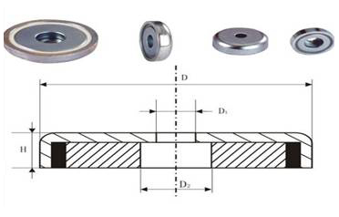

Model | D | D1 | D2 | H | Attraction(kg) | Dead Wight(g)
Pmyp-B16 | 16 | 3.5 | 6.5 | 5 | 4 | 6
Pmyp-B20 | 20 | 4.5 | 8 | 7 | 6 | 12
Pmyp-B25 | 25 | 5.5 | 9 | 8 | 14 | 23
Pmyp-B32 | 32 | 5.5 | 9 | 8 | 23 | 36
Pmyp-B36 | 36 | 6.6 | 11 | 9 | 29 | 50
Pmyp-B42 | 42 | 6.5 | 11 | 9 | 32 | 73
Pmyp-B48 | 48 | 8.8 | 15 | 11.5 | 63 | 114
Pmyp-B60 | 50 | 8.5 | 15 | 15 | 95 | 240
Pmyp-B75 | 75 | 10.5 | 18 | 18 | 155 | 471

Lifting magnet

Outer Stator
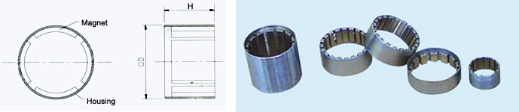

Item | House |  | Magnet
Item | Size(ODxH) | Material | Material | Poles Number
DKN25/14-15.00/12.00 | Φ25.20xΦ24.20x15.00 | 20# Steel | NdFeB | 14
DKN26/04-15.00/12.00 | Φ26.10xΦ24.10x15.00 | 20# Steel | NdFeB | 4
DKN36/04-14.00/10.00 | Φ36.00xΦ34.00x14.00 | 20# Steel | NdFeB | 4
DKN36/04-24.00/20.00 | Φ36.00xΦ34.00x24.00 | 20# Steel | NdFeB | 4
DKN36/14-22.00/18.00 | Φ36.00xΦ34.00x22.00 | 20# Steel | NdFeB | 14
DKN36/14-24.00/20.00 | Φ36.00xΦ34.00x24.00 | 20# Steel | NdFeB | 14
DKN36/14-34.00/30.00 | Φ36.00xΦ34.00x34.00 | 20# Steel | NdFeB | 14
DKN44/14-29.00/25.00 | Φ44.00xΦ42.00x29.00 | 20# Steel | NdFeB | 14
DKN44/20-19.00/15.00 | Φ44.00xΦ42.00x19.00 | 20# Steel | NdFeB | 20
DKN87/12-26.10/25.50 | Φ87.00xΦ71.20x26.16 | 20# Steel | NdFeB | 12
DKN95/04-47.60/12.70 | Φ95.30xΦ79.76x47.60 | 20# Steel | NdFeB | 4
DKN101/16-66.00/3.50 | Φ101.60xΦ90.70x66.00 | 20# Steel | NdFeB | 16
DKN108/10-49.00/12.70 | Φ108.00xΦ97.00x49.00 | 20# Steel | NdFeB | 10
DKN133/24-72.00/18.50 | Φ133.50xΦ123.60x72.00 | 20# Steel | NdFeB | 24
DKS127/20-104.80/4.00 | Φ127.00xΦ116.70x104.80 | 20# Steel | SmCo | 20
DKS133/24-63.50/18.50 | Φ133.50xΦ123.60x63.50 | 20# Steel | SmCo | 24
DKS152/20-38.10/4.00 | Φ152.40xΦ116.50x38.10 | 20# Steel | SmCo | 20
DKS213/20-38.10/22.50 | Φ212.70xΦ175.80x38.10 | 20# Steel | SmCo | 20

Outer Stator
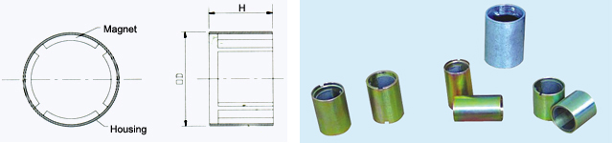
Item | House |  | Magnet
Item | Size(ODxIDxH) | Material | Material | Poles
DKN37/02-40.5/20.00 | Φ37xΦ32.8x40.50 | 20# Steel | NdFeB | 2
DKN44/04-29/25.00 | Φ44xΦ42x29.00 | 20# Steel | NdFeB | 4
DKN47/02-23/20.00 | Φ47.2xΦ38x23.00 | 20# Steel | NdFeB | 2
DKS26/02-45.2/36.00 | Φ26.1xΦ22.3x45.20 | 20# Steel | SmCo | 2
DKS30/02-30/26.00 | Φ30xΦ27x30.00 | 20# Steel | SmCo | 2
DKS32/02-42.8/31.00 | Φ32xΦ27x42.80 | 20# Steel | SmCo | 2
DKS32/02-42.80/31.00A | Φ32xΦ27x42.80 | 20# Steel | SmCo | 2
DKS32/02-44.00/23.50B | Φ32xΦ27x44.00 | 20# Steel | SmCo | 2

Ningbo Awork Magnetic Technology Co., LTD.
Add: Hongdu Road, Jiangbei District, Ningbo of China
Postcode: 315033
Tel: 0086 135 8691 2623
Fax: 0086 574 8739 2649
Email: Connie: connie.magnets@awork-magnet.com
Jane: Jane.magnets@awork-magnet.com
Maria: maria.magnets@gmail.com
Nicole: magnets1017@hotmail.com
Http : http://www.awork-magnet.com

