Micro magnet

We supply various shapes,size and materials micro magnets
We offer a wide variety of micro magnet products and services. We are good at micro magnet, normly very small and precise magnets. We can supply Alnico, NdFeB, SmCo, ferrite and other materials with very good tolerances. The size(diameter or length) could be at 0.1-10mm, and the tolerance could be +/-0.005~+/-0.02mm with various shapes.
Mini magnet / Micro magnet, we can make the dimension and tolerance with customer's request.
1. Ring Magnets
Inner hole size: <D0.6mm
Tolerance:+/-0.01mm
Thin size>=0.4mm
2. Mini Rod Magnets
Dia>=0.2mm-0.6mm
Tolerance:+/-0.01mm
3. Thin Block Magnets
Thin size>=0.5mm
Tolerance:+/-0.005mm

Micro Disc magnet
Application:
Usually for medical, sensor, precision instrument, precision measurement
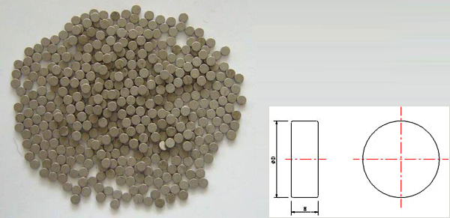
Standard size & tolerance:
 | Outer diameter(mm) | Height(mm) | PointednessR&C
Size | D0.2---D2.0 | 0.2-15 | Based on request
Tolerance | +/-0.005----+/-0.02 | +/-0.005----+/-0.02 | R+/-0.01
Material:
Smco, Ndfeb, Ferrite…etc

Micro ring magnet
Application:
Usually for medical, sensor, precision instrument, precision measurement
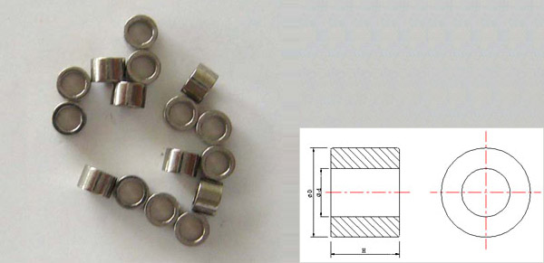
Standard size & tolerance:
 | Outer diameter (mm) | Inner diameter(mm) | Height(mm)
Size | D0.8---D10 | D0.2—D3.0 | 0.2-15
Tolerance | +/-0.005----+/-0.05 | +/-0.005----+/-0.02 | +/-0.005----+/-0.05
Material:
Smco, Ndfeb, Ferrite…etc

Micro magnet for Stepper motors of Automobil meter
Micro magnet for the Stepper motors automob ile meter, and the material is SMCO or Ndfeb.
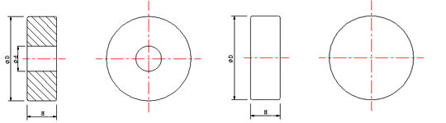
Standard size & tolerance:
 | Outer diameter (mm) | Inner diameter(mm) | Height(mm)
Size | D1.3---D2.7 | D0.2—D3.0 | 0.4---1.4
Tolerance | +/-0.005----+/-0.03 | +/-0.01---+/-0.03 | +/-0.005---+/-0.02

Ningbo Awork Magnetic Technology Co., LTD.
Add: Hongdu Road, Jiangbei District, Ningbo of China
Postcode: 315033
Tel: 0086 135 8691 2623
Fax: 0086 574 8739 2649
Email: Connie: connie.magnets@awork-magnet.com
Jane: Jane.magnets@awork-magnet.com
Maria: maria.magnets@gmail.com
Nicole: magnets1017@hotmail.com
Http : http://www.awork-magnet.com

