Samarium Cobalt

Samarium Cobalt Magnet Materials
Samarium Cobalt holds its standard property in higher maximum temperatures than neodymium, although its maximum strengh is less. The cost of SmCo material is the most expensive, so SmCo is recommended only when its performance is a high temperature environment is a concern.
1. SmCo permanent magnet has high magnetic energy product and high coercive force. Its properties are better than Alnico, ferrite permanent magnet. Its max. energy product is up to 239kJ/m3(30MGOe), which is three times of that of AlNiCo8 permanent magnet, eight times of that of ferrite permanent magnet (Y40). So the permanent magnetic component made from SmCo material is small, light and stable in property. It is widely applied to electro acoustic& telecommunication apparatus, electric motors, measure meters, peg-top electronic watch, microwave apparatus, magnetic mechanism, sensor and other static or dynamic magnetic routes.
2. The curie temp. of the SmCo permanent magnet is high and its temp. Coeff. is low. So it is suitable for use at 300, high temp.
3. SmCo permanent magnet is hear and bristle. Its rigidity strength, tensile strength and press strength are low. So it is not suitable for framework.
4. The main ingredient of SmCo permanent magnet is metal cobalt(CoY99.95%). So its price is high.
Samarium Cobalt Corrosion Characteristics (Surface Treatment)
Samarium Cobalt rare earth magnets are very resistant to corrosion and do not normally require any surface treatment.

Magnetic Properties
Sintered SmCo5 /Sm2Co17 Material Characteristics
Grade | Residual Flux Density |  | Intrinsic Force |  | Coercive Force |  | Maximum Energy Product
Grade | mT | KGs | KA/m | KOe | KA/m | KOe | KJ/m3 | MGOe
XG-16A | 800-900 | 8.0-9.0 | ＞1989 | ＞25.0 | 613-692 | 7.7-8.7 | 127±16 | 16±2
XG-16B | 800-900 | 8.0-9.0 | ＞1432 | ＞18.0 | 613-692 | 7.7-8.7 | 127±16 | 16±2
XG-20A | 880-1000 | 8.8-10 | ＞1989 | ＞25.0 | 637-756 | 8.0-9.5 | 159±16 | 20±2
XG-20B | 880-1000 | 8.8-10 | ＞1432 | ＞18.0 | 637-756 | 8.0-9.5 | 159±16 | 20±2
XG-22A | 1000-1060 | 10-10.6 | ＞2389 | ＞30.0 | 676-796 | 8.5-10.0 | 175±16 | 22±2
XG-22B | 1000-1060 | 10-10.6 | ＞796 | ＞10.0 | 637-756 | 8.0-9.5 | 175±16 | 22±2
XG-26A | 1020-1080 | 10.2-10.8 | ＞2070 | ＞26.0 | 756-836 | 9.5-10.5 | 207±16 | 26±2
XG-26B | 1020-1080 | 10.2-10.8 | ＞796 | ＞10.0 | 716-796 | 9.0-10.0 | 207±16 | 26±2
XG-30A | 1060-1150 | 10.6-11.5 | ＞1989 | ＞25.0 | 756-836 | 9.5-10.5 | 239±16 | 30±2
XG-30B | 1060-1150 | 10.6-11.5 | ＞796 | ＞10.0 | 716-796 | 9.0-10.0 | 239±16 | 30±2

Physical Properties
Physical Characteristics of Sintered SmCo
Tc Curie Temp | Tc | ℃ | 800~850 | Thermal ExpansionCoefficient | C// | 1/℃ | ~8×10-5
ρ Density | D | g/cm3 | 8.3~8.5 | Thermal ExpansionCoefficient | C⊥ | 1/℃ | ~11×10-5
μrecRecoil permeability | μrec |  | 1.00~1.05 | Bending Strength |  | N/m2 | ~1.5×108
Max. Operating Temp | T.max | ℃ | 350 | Compressive Strength |  | N/m2 | ~8×108
Electrical Resistivity |  | Ω.Cm | ~8.6×103 | Tensile Strength |  | N/m2 | ~3.5×107
Vicker | Hv |  | 500~600 | Young’s Modulus |  | N/m2 | ~1.2×1011
Thermal Permeability |  | W/mK | ~12 | Ha Magnetizing Field |  | Ka/m | ≥1600

Typical Curve
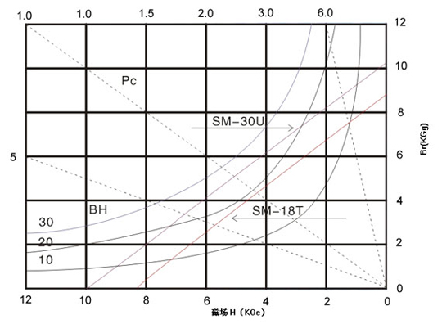

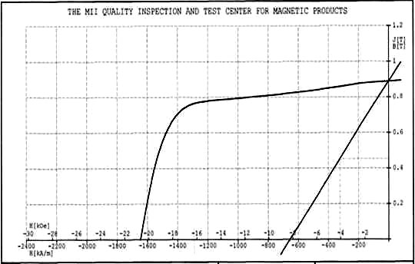

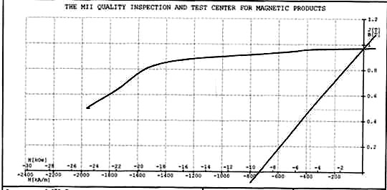

Ningbo Awork Magnetic Technology Co., LTD.
Add: Hongdu Road, Jiangbei District, Ningbo of China
Postcode: 315033
Tel: 0086 135 8691 2623
Fax: 0086 574 8739 2649
Email: Connie: connie.magnets@awork-magnet.com
Jane: Jane.magnets@awork-magnet.com
Maria: maria.magnets@gmail.com
Nicole: magnets1017@hotmail.com
Http : http://www.awork-magnet.com

